Inventory Module
Sarah and Ted buy products from local farmers and crafters. One of their frequent customers has been diagnosed with celiac disease and has approached them to include gluten free products.
As well, Sarah and Ted wonder about food recalls and how would they be able to inform their customers if they have purchased a recalled product.
Sarah and Ted would like a system that helps them organize their purchases by location, instead of having to look through a combination of online orders and paper receipts. They would like the ability to attach a copy or picture of the receipt to the purchase for tax purposes.
Please create a class diagram and sequence diagrams for the User Stories and Systems Use Case Specifications detailed below.
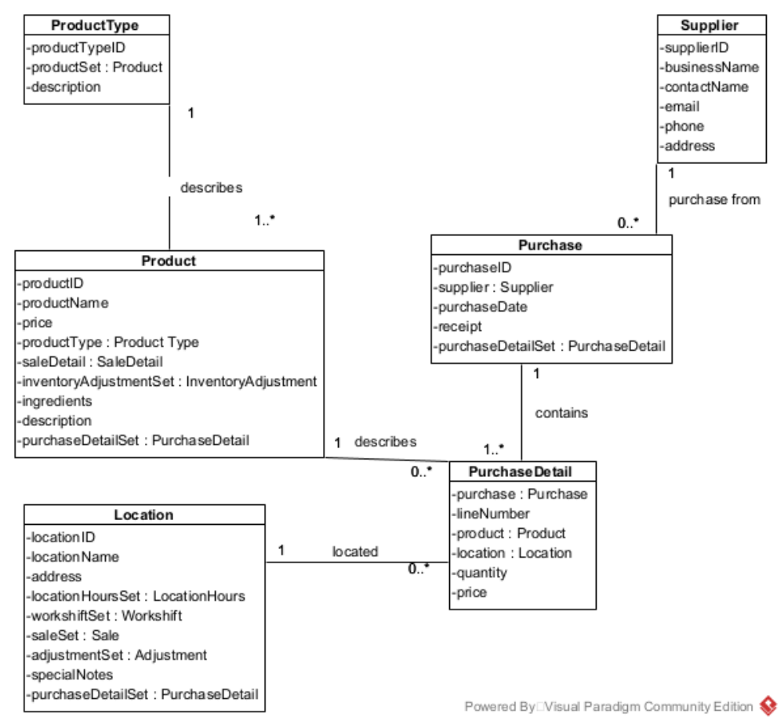
Use Case: Maintain Products
User Story
As the owner of this business, I would like to record products so that I can easily see what I’ve purchased, what I’ve sold and how much inventory that I have at each location.
Acceptance Criteria:
- Must be able to record critical information about each product.
- Allow deletion of product, in case the owner makes a mistake. Owner must be prompted to confirm and product must not be involved in any purchases or sales.
- Must be able to easily retrieve product information.
- Must be able to retrieve a list of products by product type.

Use Case Name | Create Product Information
Triggering Event | A new product of interest to the business
Brief Description | Allows the Owner to record a new product.
Actors | Owner
Related Use Cases
Preconditions | Owner has opened the Main Menu.
Post Conditions | Product is saved to the database and now can be purchased.
Flow of activities | Actor |  | System
 |  | Requests to add a new product | Displays a list of product types and prompts for selection.  Prompts for product name, ingredients, description, price
 |  | Enters name, description, and ingredients.  Selects product type | name, description and price must be entered.  product type must be selected  Generates identifier  Data is valid  Displays product  Prompts to save
 |  | Request to save | Saves the product and returns to the main menu
Exception Conditions | - Owner chooses to cancel adding the product
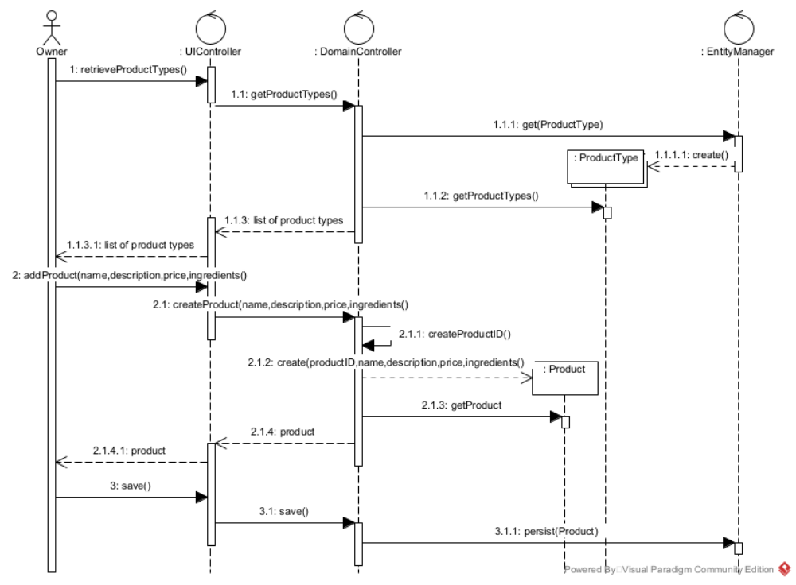

Use Case Name | Query Products by Product Type
Triggering Event | List of products required
Brief Description | Allows the Owner to query products
Actors | Owner
Related Use Cases
Preconditions | Owner has opened the Main Menu.
Post Conditions | Product information provided to the actor.
Flow of activities | Actor |  | System
 | 1. | Requests to products | Displays a list of product types and prompts for selection
 | 2. | Selects product type | Displays a list of products for that product type
Exception Conditions | - Owner chooses to cancel query products

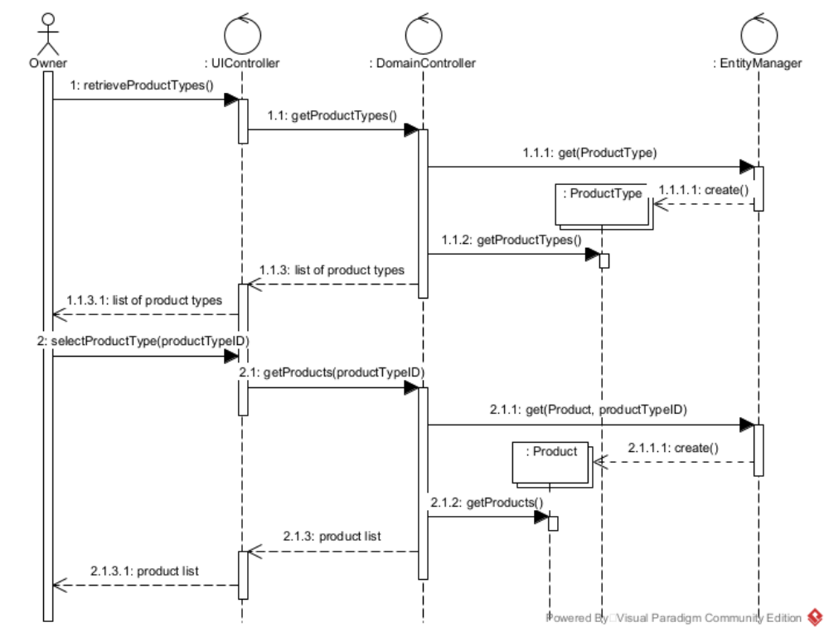

Use Case: Maintain Purchase
User Story
As the owner of this business, I would like to record my purchases so that I can quickly see how much money I’ve spent, what I’ve ordered and from where. With each purchase, I want to record which location received the product. Because I like to order in bulk, I must be able to record multiple locations for each product.

Acceptance Criteria:
- Must be able to record purchases by supplier.
- Must be able to query purchase details by location.

Use Case Descriptions

Use Case Name | Create Purchase
Triggering Event | Purchase of products.
Brief Description | Allows the Owner to record a new purchase.
Actors | Owner
Related Use Cases
Preconditions | Owner has opened the Main Menu.
Post Conditions | Purchase is saved to the database and now can be queried.
Flow of activities | Actor |  | System
 | 1. | Requests to add a new purchase | Displays a list of suppliers and prompts for selection. Prompts for purchase date and selection of receipt file location.
 | 2. | Selects a supplier.  Enters purchase date and receipt file selected. | Verifies that a supplier was selected Verifies that date was entered and receipt selected.  Creates a unique identifier for the purchase. Displays the purchase Prompts to enter purchase details.
 | Loop | Chooses new product | Displays a list of products, sorted by product type and prompts for selection.
 | 3. | Selects a product | Display a list of locations and prompts for select. Prompts for quantity.
 | 4 | Selects location and enters quantity and price | Creates a unique identifier for the detail.  Data is valid  Extended price is calculated (price * quantity ordered)  Taxes are calculated and displayed  Purchase total is updated with the extended price + taxes  Purchase tax is updated with the tax amount  Displays purchase including totals, date and list of products and locations  Prompts to add another location
 |  | Repeats above step until all locations for a product were selected | Display a list of products and prompts for selection
 | End | When all products are selected | Prompts to save purchase
 | 5. | Chooses to save | Saves the purchase and returns to the main menu
Exception Conditions | - Owner chooses to cancel adding the purchase

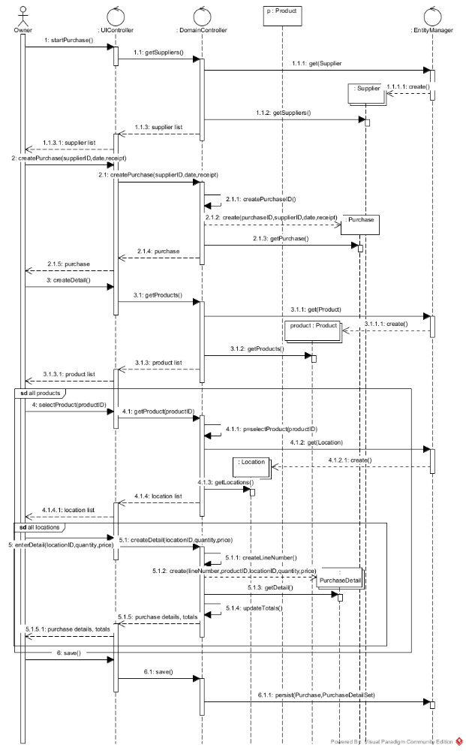
Use Case Name | Query Purchases
Triggering Event | Owner requires a list of purchases for a date period listing Supplier, Products quantity purchased, price paid and the extended amount (price * quantity)
Brief Description | Allows the Owner to retrieve purchases for a specified date range
Actors | Owner
Related Use Cases
Preconditions | Owner has opened the Main Menu.
Post Conditions | purchases are retrieved, totaled and displayed
Flow of activities | Actor |  | System
 | 1. | Requests to query purchase (by date) transactions | Displays a calendar
 | 2. | Selects date range | Verifies that dates are selected  Retrieves purchases in the specified date range, calculating totals  Prompts to exit
 | 3. | Request to cancel | returns to the main menu
Exception Conditions

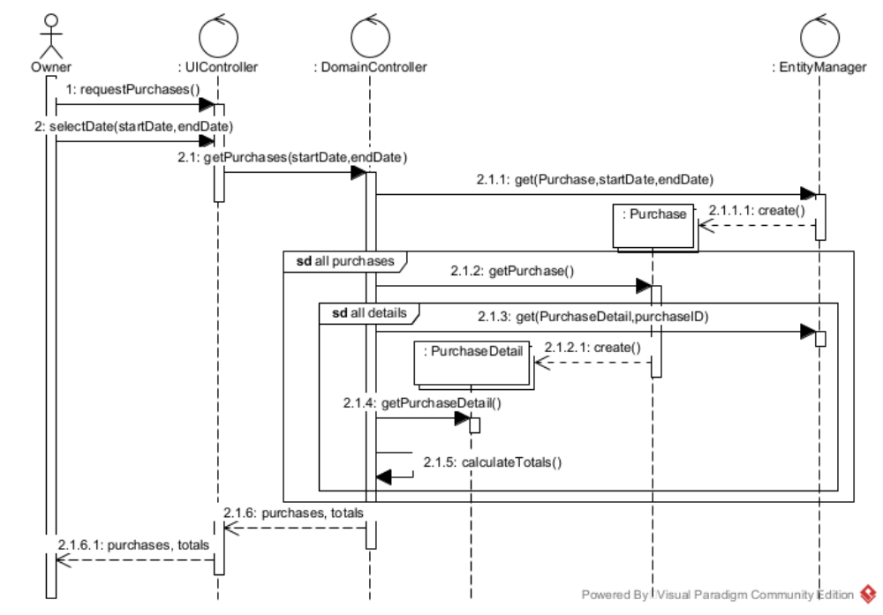

Your tasks:
- Create a class diagram to support the above case study and Systems Use Case Specifications
- Create sequence diagrams for the above Systems Use Case Specifications.

